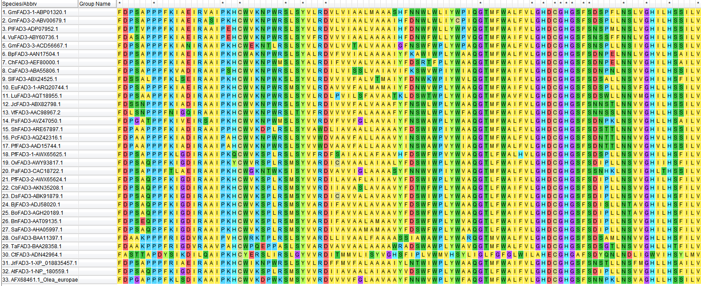
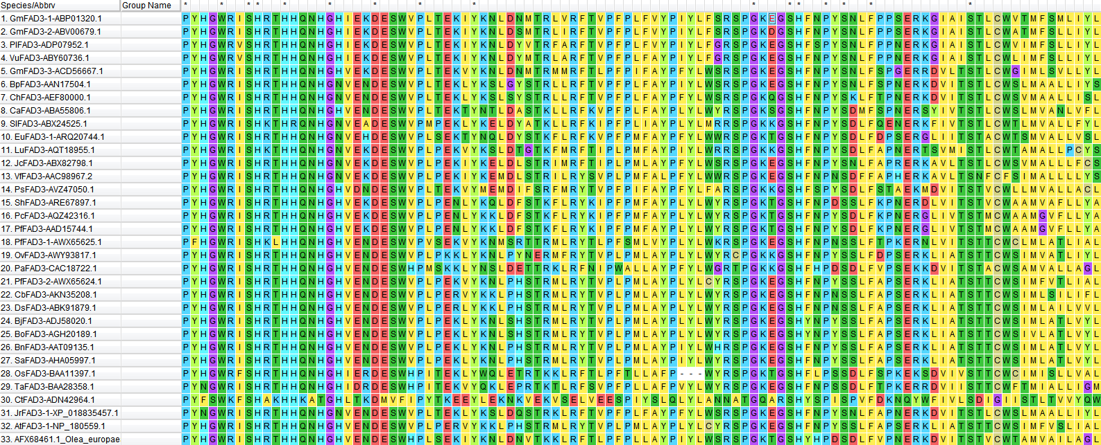

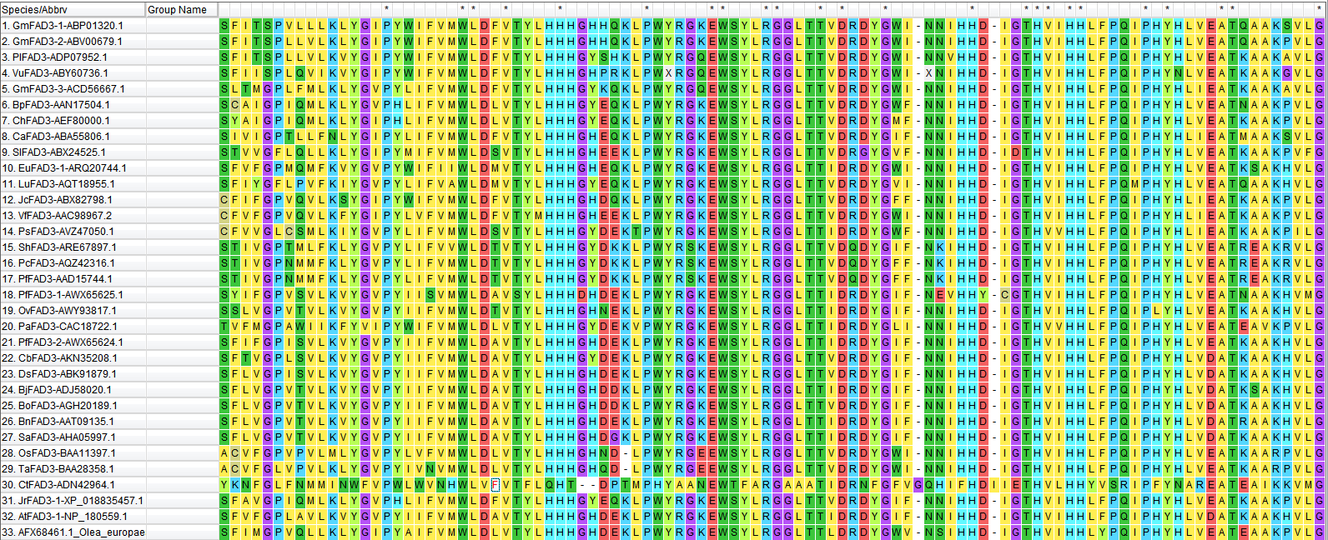

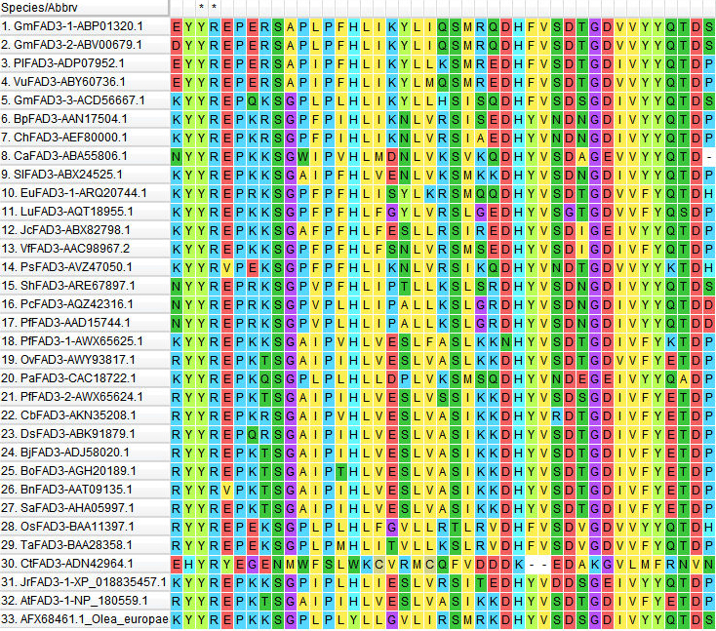
Supplementary Fig. 5 Multiple conserved sequence alignment of FAD3 proteins in 32 species
Note: dicot monocots gymnosperm fungi

